

Media Release Contact: E. Lenita Johnson 816-651-7777 For Immediate Release estelljohnson@sbcglobal.net

Cities Turn Green as Voices Unite to Fight Injuries and Violence
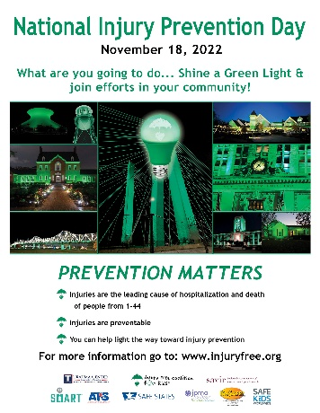
(New York) When the sun goes down on Friday, November 18th darkened skylines across the country will be peppered with a warm hue of green as bridges, monuments, government buildings and businesses join hospitals and trauma centers and become beacons of light raising awareness about the need to address injuries and violence, the number one killers of people 1-44 years old. It will mark the end of the 3rd National Injury Prevention Day, a day where the nation’s top prevention advocates join forces to raise their voices together and push for change.
The Injury Free Coalition for Kids, Safe Kids Worldwide, Safe States Alliance, the American Trauma Society, the American Academy of Pediatrics, Be SMART -- a program of Everytown for Gun Safety Support Fund, The Society for Advancement of Violence and Injury Research, the Trauma Center Association of America, JPMA Cares and I’m Safe are among those working to raise awareness about the problem and to provide communities the tools to make a difference.
They are working for change in a year where lives were taken in areas deemed safe: homes, playgrounds schools, and grocery stores. They are trying to stop the heartache needlessly left by preventable injuries and deaths from of more than 40 mass shootings, large numbers of lives taken by handguns, fires, motor vehicle crashes, drownings and drug overdoses.

“Injuries and violence touch everyone whether it be our children, family members, parents, spouses or ourselves but many are preventable,” Barbara Barlow, MD, Professor of Surgery in Epidemiology at Columbia University and Founder of the Injury Free Coalition for Kids said. “We must promote the use of safe practices, using safety products, and the implement of strong legislative policies.”

The day begins with a one-hour webinar at 10:00 am EST, where Christopher Jones, PharmD, DrPH, MPH, the CDC’s Acting Director for the National Center for Injury Prevention and Control (NCIPC) and a US Public Health Service Captain will join the country’s top injury and violence prevention organizations to sound the alarm about the need for prevention.

TCAA’s Injury Prevention Committee will present the winners of its Nationwide NIPD media contest "What Safety Looks Like in Your Community." Safe States will share the outcome of an NIPD sign-on to an organizational support letter. At 1:00 p.m. (EST), the public is invited to join everyone and take part in a live national conversation about the country’s top injury and violence concerns during a one-hour twitter chat using the hashtag #BeInjuryFree. Throughout the day a number of cities will focus on, be shown how to use and be given tools to create safer environments and to learn more about National Injury Prevention Day activities go to https://injuryfree.org/nationalinjurypreventionday/2022.

"National Injury Prevention Day is an opportunity to highlight the evidence-based strategies that can prevent injuries, and to recognize the importance of research in discovering what works to save lives," stated Dr. Theresa Cruz, Past President of the Society for Advancement of Violence and Injury Research. "Researchers have identified multiple strategies for preventing injury and violence including use of safety devices, policy and environmental changes, and addressing social determinants of health like poverty and racism."

For more information about National Injury Prevention Day or to arrange an interview in advance, please contact E. Lenita Johnson 816-651-7777 or e-mail .

The Injury Free Coalition for Kids is a part of the outreach arm of the ICRC located in the Columbia University Center for Injury Science and Prevention

